Jordan Mitchell

10/4/2024

Professor Farley

Journal: Software Testing Techniques

In the past few modules, I've developed several components for a contact service, task service, and appointment service, each with unique functionality and testing requirements. These assignments emphasized the importance of unit testing in verifying the functionality and correctness of the code. The focus was on creating modular software components that allowed for adding, updating, and deleting data, while verifying their robustness through JUnit tests. I used techniques like boundary testing and exception handling to ensure the reliability of my programs. I will discuss the various software testing techniques I utilized during these assignments and analyze their viability in real-world software development applications.

**What were the software testing techniques that you employed for each of the milestones? Describe their characteristics using specific details.**

Throughout the milestones in Modules Three, Four, and Five, I made use of unit testing as my primary testing technique. In Module Three, for the contact service, I utilized boundary testing, ensuring that contact IDs, names, phone numbers, and addresses adhered to the specified requirements. Specifically, JUnit tests were written to validate input lengths, confirming that no strings exceeded the character limits.

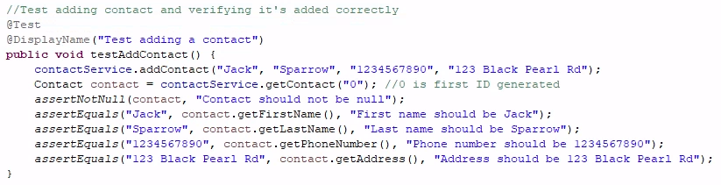

In Module Four, for the task service, similar testing was used, focusing on validating that task IDs, names, and descriptions followed the length restrictions. Additionally, exception handling was implemented to verify that the code properly handled invalid inputs, such as null values or overly long strings.

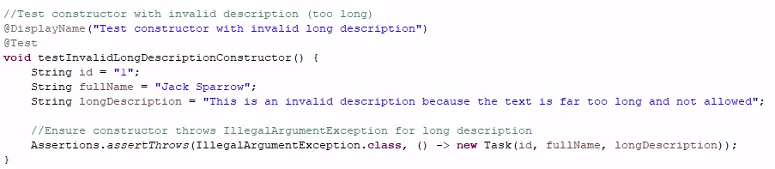

In Module Five, for the appointment service, I broadened my approach to include tests for both future and past appointment dates, ensuring that the code correctly handled scheduling logic and rejected appointments set in the past.

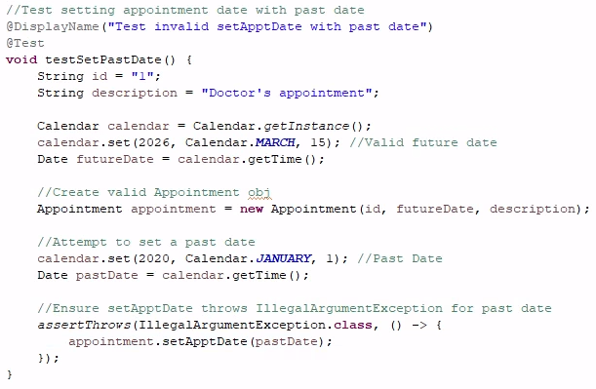

**What are the other software testing techniques that you did not use for the milestones? Describe their characteristics using specific details.**

In addition to the unit testing approach I used in the milestones, there are several other software testing techniques that were not applied. One technique is integration testing, which focuses on ensuring that different modules or components of a system work together properly. This could involve testing how the AppointmentService class interacts with other potential services, like a user authentication system or a database for storing appointments. Integration testing helps detect issues that occur when components are combined, even if the individual components work properly on their own. Another helpful technique is system testing, where the entire system is tested as a whole. This would include running tests on the complete software package, including all integrated components, to verify the overall functionality meets requirements. System testing would ensure that my appointment scheduling system behaves as it should when deployed in a real-world situation.

Acceptance testing is another approach, typically done by users or clients to validate if the software meets their needs. For example, users would test whether they can create, modify, and delete appointments as expected. This type of testing focuses on making sure the software provides a satisfactory experience for consumers. In addition to these, there is performance testing, which measures how the system performs under different conditions, like high traffic or large amounts of data. This could be relevant to my assignments if the services were expected to handle a large number of users or appointments, testing for speed, reliability, and resource efficiency. Finally, regression testing confirms that changes or updates to the code do not create new bugs in previously tested work. For example, if I added a new feature like sending appointment reminders, regression testing would ensure that the existing features still function correctly.

**For each of the techniques you discussed, explain the practical uses and implications for different software development projects and situations.**

Out of all the software testing techniques, unit testing was my preferred approach, especially for the situations presented in the milestones. Unit testing allows for thorough validation of individual methods and components in isolation, ensuring that each part of the program works correctly before integration. For example, in both the AppointmentServiceTest and ContactServiceTest, unit tests ensured that the methods for adding, updating, and deleting entries behaved as expected. I enjoyed unit testing for this as it let me know where the faults in my code were and allowed me to make alterations. Often times, a good amount of my code functioned properly, but there were errors in other sections that prevented the code from executing fully. Another reason I enjoy unit testing is because it's highly focused and quick to perform. Each test is designed to cover a specific piece of functionality, which makes debugging and identifying issues much easier. For example, when testing the setDescription method in the Appointment class, I was able to pinpoint validation issues related to the length of descriptions early in development. I like that it accounts for typical situations that may be faced when in operation, like a user attempting to set a date that in the past.

Beyond unit testing, other techniques like integration, system, and regression testing are equally important depending on the scale and complexity of the software. Integration testing, for instance, would be highly useful in projects where multiple components or services must interact. It verifies that the interactions between each module works as expected. For example, in larger applications, testing the interaction between a database and the application layer ensures that data flows correctly between them. System testing comes into play when testing the software in its entirety, beyond the individual components. In projects where end-to-end functionality has to be verified, system testing confirms that the software behaves as expected in real scenarios. This is most applicable in larger-scale applications where multiple subsystems come together to form a comprehensive program, such as e-commerce websites or mobile apps, where both functionality, performance, and security are important to verify. Finally, regression testing is vital to maintaining and expanding existing code. In situations where features are regularly updated or bugs are fixed, regression testing ensures that these changes don’t break existing functionality as a result. This is especially important for large, ongoing projects, such as software with frequent version updates, guaranteeing stability throughout development.

**Conclusion**

Overall, the testing techniques I used throughout the milestones, specifically unit testing, have proven essential in ensuring the reliability and functionality of my code. Unit testing allowed me to detect issues early on within the specific methods of the the Task, Contact, and Appointment services, providing me with a clear and focused approach to debugging. Although unit testing was most effective for these assignments, other techniques like integration testing, system testing, and regression testing offer additional layers of security and stability, particularly in larger and more complex projects. Each method has its place in the software development process, helping create robust and reliable applications that meet expectations. In combining these techniques, developers can make sure they take a thorough approach to quality assurance by addressing both individual components and their overall interaction within the entire system.